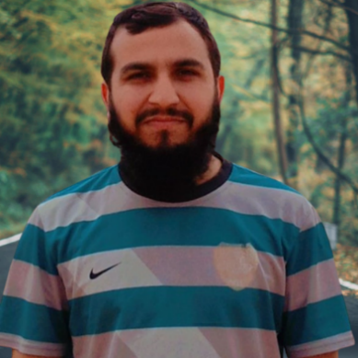

**Bilal Ahmad**



I enjoy working as part of an efficient team. I am capable of working on my own initiative and possess excellent organizing abilities and excellent communication skill and enrich my knowledge to help in the process of organization. I always work hard and efficiently to achieve my goal and meet deadlines.

+92 3129320970

**CONTACT**



**PROJECTS / WORK**

**Diploma**

Ghari Liaqat Abad Mera Kachori, Peshawar,Pakistan

bilalahmad8739@gmail.com

**Research and Development**

Comparative Analysis on Hepatitis Prediction

* Cricket
* Video Gaming
* Swimming

**Hobbies**

English, Urdu and Pashto

**LANGUAGES**

* MS Office
* Typing (40 wpm)
* Video Editing
* Web Development
* Android Development
* Data Entry

**SKILLS**

**2016 Metric (Grade: A) – BISEP**

Azeem Public School Peshwar

**2017 F.Sc – Computer Science (Grade: A) – BISEP**

Government College Peshawar

**2022 BS Software Eng. (CGPA: 2.87) – HEC – In Progress**

City University of Sciences and Information Technology Peshawar

**EDUCATION**

**2016 DIT**

Aptech Institute Peshawar